|



**Principios para Iot**

Ing. DAVID OCHOA DEL TORO

**TDSM – 4”B”**

**Lucero Alhely Barraza Cedillo**

**Circuito 1**

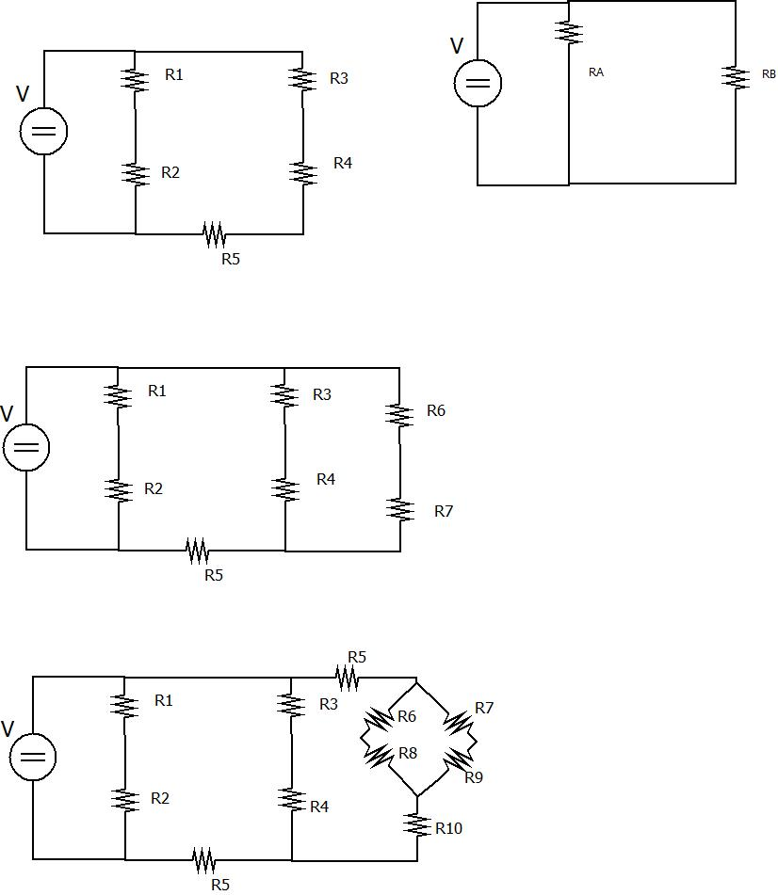

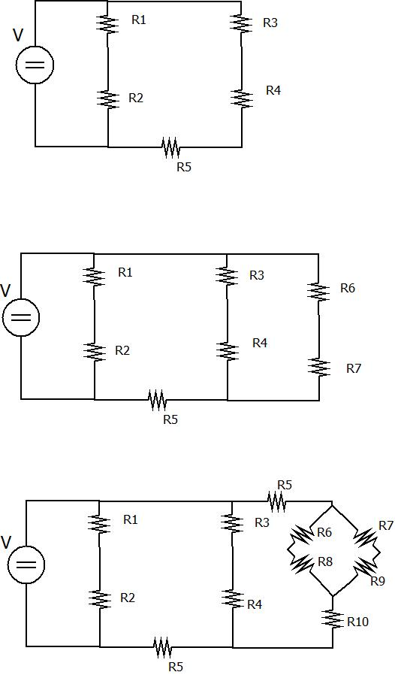

|  |  |  |  |
| --- | --- | --- | --- |
| **ID** | **R** | **I** | **V** |
| 1 | 10K | 1.043 | 10.43 |
| 2 | 1.5K | 1.043 | 1.564 |
| 3 | 5.2K | 1.176 | 6.115 |
| 4 | 3.2K | 1.176 | 3.763 |
| 5 | 1.8K | 1.176 | 2.122 |
| T | 5.4083 | 2.2188 | 12 V |

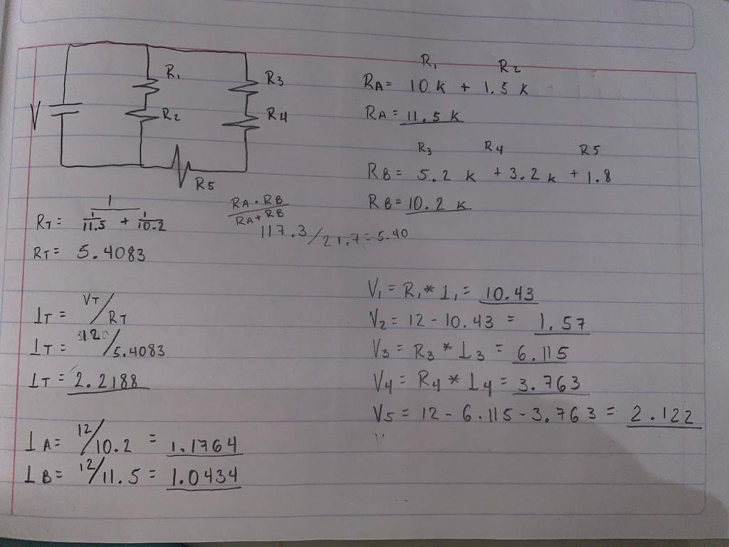

**Voltaje**

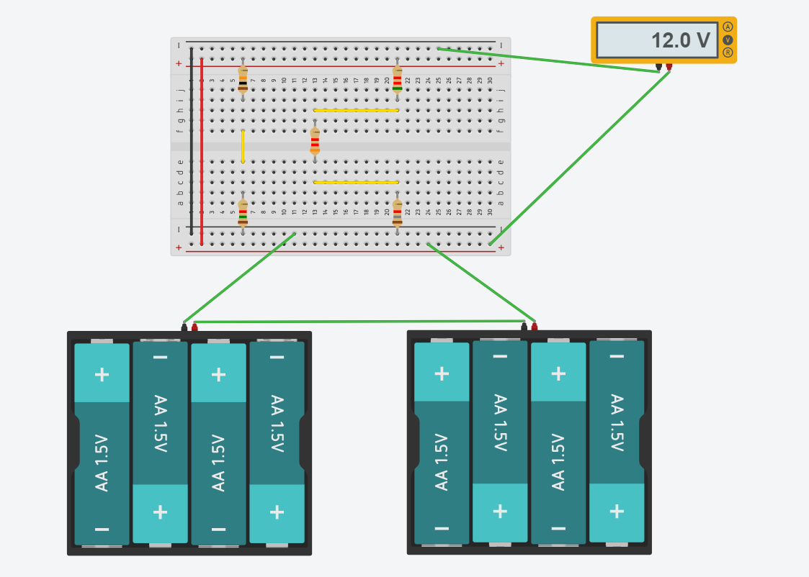

**Resistencia**

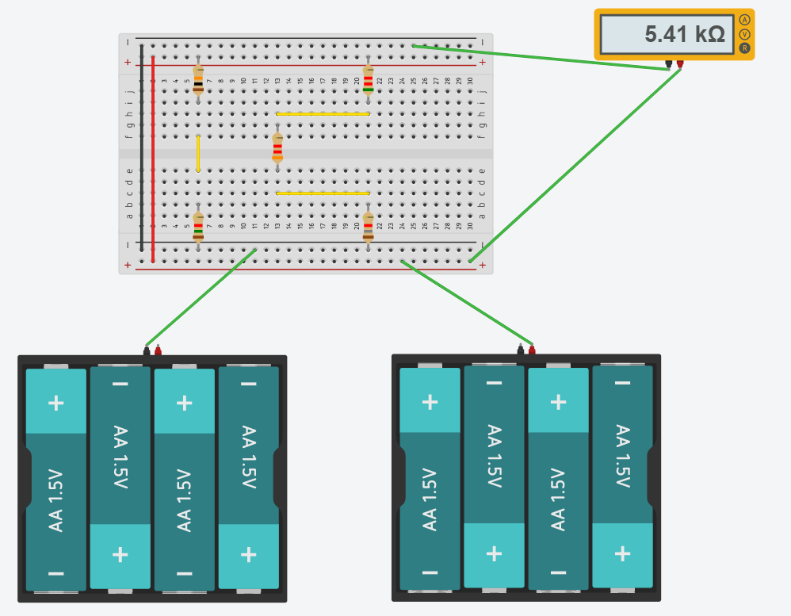

**Corriente**

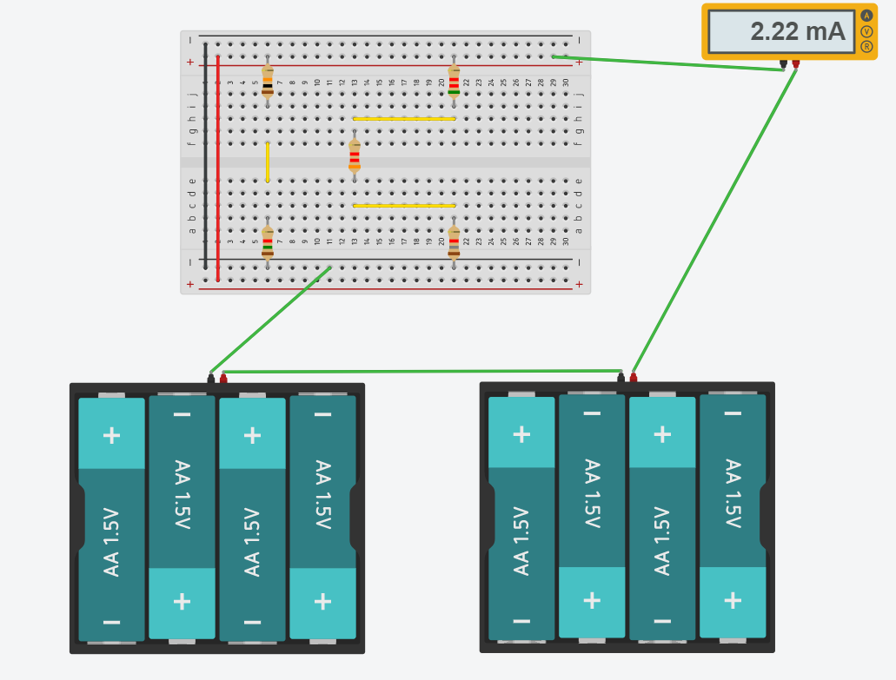

**Voltaje general**

